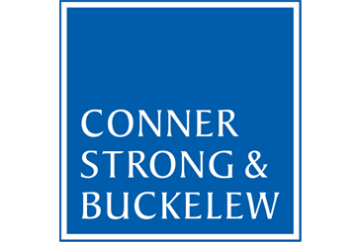
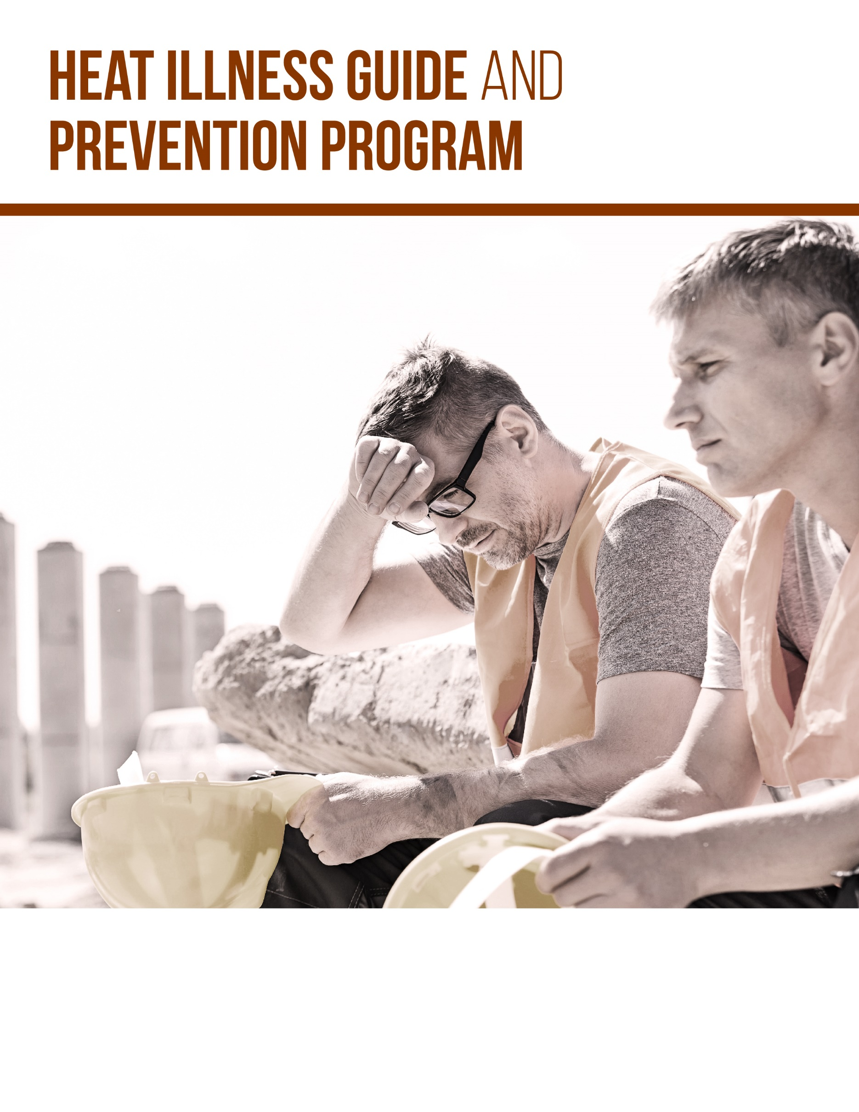
© 2019 Zywave, Inc. All rights reserved.
HEAT ILLNESS GUIDE
INTRODUCTION 4
HOW THE HUMAN BODY HANDLES HEAT 5
Increasing Blood Flow 5
Sweating 5
HEAT ILLNESSES 6
Heat Rash 6
Heat Cramps 6
Heat Exhaustion 6
Heatstroke 6
FACTORS THAT CONTRIBUTE TO HEAT ILLNESS 8
Heat From Activity 8
Heat From the Environment 8
Personal Risk Factors 10
SAFEGUARDING EMPLOYEES 12
RECOGNIZING AND TREATING HEAT ILLNESSES 12
CONTROLLING HEAT ILLNESSES 14
Heat Illness Assessments 14
Heat Illness Control Plans 14
Employee Training 16
HEAT ILLNESS PREVENTION PROGRAM 19
Application 19
Roles and Responsibilities 19
Heat Stress Control Measures 20
Heat-related Illnesses and Emergencies 20
Training 20
Program Review 21
Table 1.1 22
HEAT ILLNESS PREVENTION POLICY 19
HEAT ILLNESS PREVENTION PROGRAM 19
HEAT ILLNESS HAZARD ASSESSMENT CHECKLIST 23
THE HAZARDS OF HEAT POSTER 25

INTRODUCTION
While it’s best not to work outside in high temperatures, the nature of certain jobs—like construction, forestry, manufacturing or landscaping—sometimes makes it unavoidable. When this happens, a worker’s body temperature can rise to dangerously high levels and put them at risk of serious health complications.
Normally, the human body cools itself through sweating. However, in hot and humid weather, sweating is often not enough and heat illnesses can occur.
As an employer, you have a duty to take every reasonable precaution to protect your workers. Under the General Duty Clause, the Occupational Safety and Health Act (OSHA) Act of 1970, employers are required to provide a workplace free from potential hazards that can cause or are likely to cause death or serious harm to employees, including heat-related hazards.
In order to protect the well-being of their workforce, employers often need to implement policies and procedures to protect workers in hot environments. Accordingly, any employer that mandates outdoor work or work in hot environments should be educated on heat illnesses in order to thoroughly protect its workers. In addition, training employees on heat illness and general safety practices can make all the difference when it comes to protecting them from the heat.
It should be noted, some states have specific standards when it comes to heat illnesses so be sure to check local regulations.
This Heat Illness Guide and Prevention Program is designed to provide a background on heat illnesses, including how the body handles heat, the different types of heat illnesses and specific risk factors. In addition, the resources found at the end of this guide will detail safety and prevention controls, and will provide organizations with real policies and strategies to help ensure a safe and healthy workforce.

Conner Strong & Buckelew is your workplace safety and risk management partner. We care about the well-being of your employees and your business. Contact us today for more tools and resources to ensure the health and safety of your workforce.

HOW THE HUMAN BODY HANDLES HEAT
While the human body is typically good at expelling excess heat, outside factors like temperature, humidity, airflow, clothing and personal risk factors can complicate the process. In general, the human body can release heat either by increasing blood flow or by sweating.

Increasing Blood Flow
When dealing with high body temperatures, an individual’s bloodstream will often transfer excess heat to the skin. And, when the air is cooler than the skin, heat is transferred to the surrounding air in a process called convection. This is why a person’s skin can appear red or flushed during hot weather.

Sweating
When an individual gets hot, the brain tells the body to sweat. The body begins to cool as the sweat evaporates from the skin. This is the best way for the body to cool itself at temperatures over 95 degrees Fahrenheit.
While sweating is an effective way for the body to reduce its temperature, anything that limits or prevents sweat from evaporating from the skin can complicate the process. This can include the following scenarios:
- An individual is not acclimatized to hot environments.
- An individual has a skin condition that limits sweating.
- An individual is taking medication that limits or prevents sweating.
- An individual is dehydrated or not drinking enough fluids.
Sweat evaporation can also be impacted by humidity, airflow and certain kinds of clothing. In general, high humidity and protective clothing are likely to hinder sweat evaporation, contributing to heat illnesses.

HEAT ILLNESSES
Hot weather, especially when combined with strenuous physical labor, can cause body temperatures to rise to unsafe levels—leading to heat illnesses. Outdoor workers are especially vulnerable to heat-related illnesses because they spend the majority of the day outside in direct sunlight.
There are a variety of heat illnesses, including heat rash, heat cramps, heat exhaustion and heatstroke. Each of these illnesses vary in symptoms and severity, but commonly cause dizziness, weakness, nausea, blurry vision, confusion or loss of consciousness.

Heat Rash
Heat rash is a red, bumpy rash characterized by severe itching. Heat rash is often caused by hot, humid environments and plugged sweat glands. It is one of the most common types of rashes and is often uncomfortable and painful.

Heat Cramps
Heat cramps are muscle spasms that usually affect the arms, legs or stomach. They are the most common type of heat-related illness.
Heat cramps are caused by heavy sweating, especially when water is not replaced quickly enough. Typically, symptoms do not occur until after work, at night or when relaxing. Although heat cramps can be quite painful, they usually don't result in permanent damage.

Heat Exhaustion
Heat exhaustion is a more serious condition than heat cramps. It occurs when the body's internal temperature regulating system is overworked, but has not completely shut down.
In cases of heat exhaustion, the surface blood vessels and capillaries—which are meant to enlarge to cool the blood—collapse from loss of body fluids and necessary minerals. This happens when individuals do not drink enough fluids to replace what they are sweating away.
Common symptoms of heat exhaustion can include the following:

- Headaches
- Heavy sweating
- Intense thirst
- Dizziness or fatigue
- Loss of coordination
- Nausea or vomiting
- Impaired judgment
- Lightheadedness
- Loss of appetite
- Hyperventilation
- Tingling in hands or feet
- Anxiety
- Cool and moist skin
- Weak and rapid pulse
- Low blood pressure

Heatstroke
Heatstroke is a life-threatening illness with a high death rate. It occurs when the body has depleted its supply of water and salt, and the affected individual’s core body temperature rises to deadly levels.
A heatstroke victim may first suffer heat cramps and/or heat exhaustion before progressing into the heatstroke stage—but not always. It is important to note that heatstroke symptoms are similar to those of a heart attack. Therefore, it is very important to know how to recognize the signs and symptoms of heatstroke and to check for them any time an employee collapses while working in a hot environment.
Symptoms of heatstroke are the same as those for heat exhaustion but can also include any of the following:

- A high body temperature (at least 102 degrees Fahrenheit)
- A distinct absence of sweating
- Hot, red or flushed dry skin
- Rapid pulse
- Difficulty breathing
- Constricted pupils
- Headache
- Vomiting or confusion
- Bizarre behavior
- High blood pressure
- Fainting
- Seizures
- Excessive sweating
- Nausea
Advanced symptoms may include seizures, convulsions, collapse, loss of consciousness and a body temperature over 104 degrees Fahrenheit.

FACTORS THAT CONTRIBUTE TO HEAT ILLNESS
When working outdoors or at high temperatures, heat can come from a multitude of sources and negatively affect employees. Specifically, body temperatures commonly increase after strenuous work activity or when the body absorbs heat from the environment. In some cases, heavy work activity can be the main source of heat, and an employee could suffer symptoms of heat illness even at relatively low temperatures. Personal risk factors can also contribute to overheating.

Heat From Activity
Workers’ internal temperatures can rise to dangerous levels if they overexert themselves. In general, sustained levels of moderate or heavy physical activity can increase an individual’s risk of heat illness. The following are some examples of light, moderate and heavy levels of activity to be aware of in order to manage your employees’ workloads:
Level of Activity | Activity | Real-world Examples
Light | - Sitting, using arms and legs moderately to perform jobs  - Standing while performing simple tasks  - Casual walking | - Desk work  - Assembly-line work  - Supervising
Moderate | - Brisk walking  - Sitting, using hands and arms vigorously  - Standing while performing somewhat complex tasks  - Occasional lifting or pushing | - Delivering mail  - Using heavy machinery  - Picking fruit and vegetables  - Warehouse work
Heavy | - Construction tasks  - Intermittent heavy lifting, pushing or pulling  - Climbing stairs with heavy gear | - Sawing, planting, digging, shoveling and roofing  - Restocking shelves and asbestos removal  - Firefighting

It should be noted that the above chart does not take into account heat created by gear, radiant sources or the environment.

Heat From the Environment
The level of external heat affecting workers is often related to the surrounding air temperature, the amount of air movement and sources of radiant heat. Radiant heat can come from a variety of sources, including heaters, boilers, fires and the sun.
In terms of protecting outdoor workers, consider limiting or halting work if one or more of the following is true:
- Temperatures begin to rise to dangerous levels (see heat index chart below).
- Humidity increases to extremes.
- Heat from the sun intensifies.
- There is an absence of air movement.
- Proper controls are not in place to reduce the impact of radiant heat.
- Work is too strenuous for conditions.
The heat index, which takes into account both temperature and humidity, should be used as an indicator for employers. To determine if the air temperature and humidity are safe for outdoor work, use the chart below.
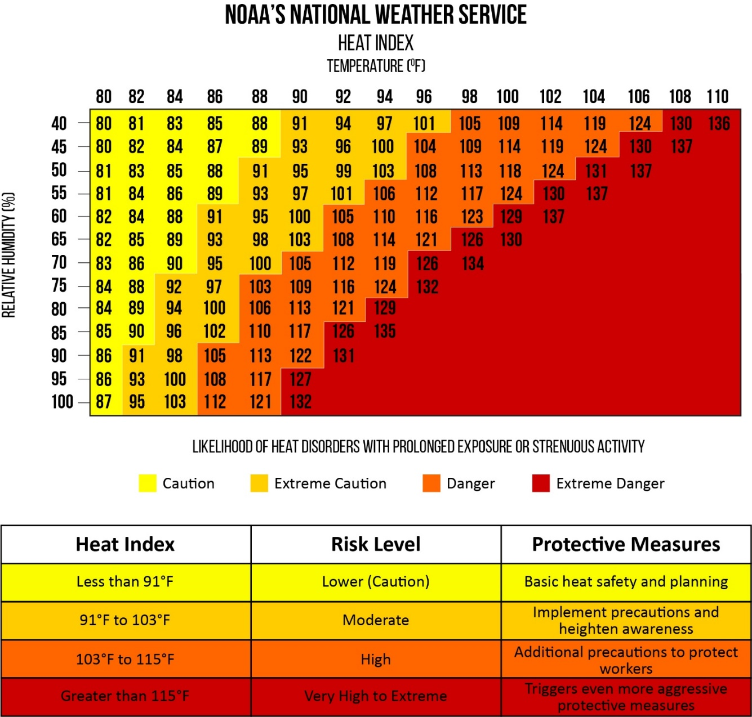

(Source: NOAA)

Personal Risk Factors
In addition to heat generated from activity and the environment, certain personal factors can cause an individual to overheat. People respond to heat differently, and employers should be aware of the following factors that could increase an employee’s risk of experiencing a heat illness:
- Acclimatization—Acclimatization refers to an individual’s heat tolerance. Those who don’t work at high temperatures regularly are more likely to experience heat illnesses.
- Poor physical fitness and obesity—Physically fit individuals can generally cope with heat more easily than those who are not. Regular aerobic activity—like walking, running or swimming—can help improve an individual’s tolerance to heat. In addition, excess fat leads to increased insulation. This means individuals who are overweight retain and generate more heat.
- Age—Those over the age of 40 are generally more susceptible to the effects of heat. Elderly populations are even more susceptible to heat-related conditions. In some cases, heart function decreases and sweating occurs at a slower rate for those over 40.
- Pre-existing medical conditions or treatments—Common medical conditions can affect a person’s ability to handle heat. Specifically, heart problems and the low-salt diets used to treat them can weaken the body’s ability to expel heat efficiently. Other conditions that can affect a person’s ability to deal with heat include diabetes, kidney problems, pregnancy, cystic fibrosis and hyperthyroidism.
- Short-term disorders and minor illnesses—Fevers, diarrhea and vomiting lead to a loss of fluids, which can greatly impact how an individual copes with heat. Sleep deprivation has also been known to increase the risk of heat illness.
- Chronic skin disorders—Rashes, dermatitis, healed burns and other conditions that impact large areas of the skin can reduce the body’s ability to sweat.
- Use of medication—Certain medications impact the body’s ability to sweat. The following are just some examples of medications that could put a worker at risk:
  - Anticholinergic drugs
  - Antihistamines
  - Antipsychotic phenothiazines
  - Beta blockers
  - Calcium channel blockers
  - Diuretics
  - Lithium
- Alcohol or drugs—Alcohol is known to increase water loss and can cause dehydration in some cases. In addition, certain street drugs increase the body’s internal temperature and its ability to expel heat.
- Previous heatstroke—Once workers have experienced heatstroke, they are more likely to suffer from another one. As such, these individuals often require special protection.

SAFEGUARDING EMPLOYEES
Understanding heat illnesses and their contributing risk factors is a good first step for employers. However, to keep their workers safe, organizations must know how to limit and treat heat illnesses. In addition, implementing workplace controls can make all the difference when it comes to protecting at-risk employees from potentially deadly heat.
RECOGNIZING AND TREATING HEAT ILLNESSES
As an employer, you need to know how to recognize and treat heat illnesses if you are to protect your workers. Understanding how to respond to the symptoms of heat illnesses can mean the difference between life and death.
Use the chart below to understand the different signs, symptoms, treatment methods and prevention procedures for common heat illnesses. Remember, it is always advisable to be overcautious when it comes to heat illness. Don’t hesitate to seek medical care for employees who exhibit a form of heat illness. Doing so can save lives and protect your business.
Heat Illness | Causes | Symptoms | Treatment | Prevention
Heat rash | - Hot, humid environments  - Plugged sweat glands | - Red, bumpy and itchy rash  - Usually appears on the neck, upper chest, groin, under the breasts and in elbow creases | - Change into dry clothes  - Avoid hot, humid environments  - Do not use ointments and creams | - Wash skin regularly to keep it clean and dry
Heat cramps | - Heavy sweating from strenuous activity that drains a person’s body of fluid and salt | - Painful cramps in commonly worked muscles, like the arms, legs or stomach  - Cramps come on suddenly, either at work or later in the day  - Muscle spasms or pain  - Note: Heat cramps can be a symptom of more serious heat-induced illnesses | - Move to a cool, shaded area  - Loosen clothing and stretch affected muscles  - Drink cool, salted water or an electrolyte-replacement beverage  - Seek medical aid if cramps are severe or don’t go away after fluid replenishment | - Reduce activity levels  - Avoid heat  - Drink fluids regularly  - Use the buddy system to help spot signs of heat illnesses
Heat exhaustion | - Fluid loss and inadequate salt and water intake  - The body’s cooling system begins to break down | - Heavy sweating  - Cool, moist skin with body temperatures over 100.4 F  - Weak or fast pulse and normal or low blood pressure  - Weakness, nausea and vomiting  - Thirst alongside panting or rapid breathing  - Blurred vision  - Headache, light headedness or dizziness  - Irritability | - Seek medical attention immediately  - Move the person to a cool, shaded area  - Loosen or remove clothing  - Provide cool water and never leave the person alone  - Cool the person with cold compresses, ice and ice packs | - Reduce activity levels  - Avoid heat  - Drink fluids regularly  - Use the buddy system to help spot signs of heat illnesses
Heatstroke | - A classic heatstroke occurs in older adults and in persons with chronic illnesses; it occurs when a person’s body has used up its water and salt reserves  - Exertion heatstroke generally occurs when a person engages in strenuous activity for long periods of time in the heat; the body’s cooling system is exhausted and cannot get rid of excess heat | - Body temperatures increase over 104 F  - Weakness  - Confusion  - Hot, dry and red skin  - Profuse sweating  - Fast pulse  - Headache or dizziness  - Fainting or convulsions | - Call an ambulance, as heatstroke can kill quickly  - Place worker in shady, cool area  - Remove excess clothing  - Fan the victim  - Spray the victim with cool water, apply ice packs, cool compresses or ice if available  - Provide cool water and never leave the person alone | - Reduce activity levels  - Avoid heat  - Drink fluids regularly  - Use the buddy system to help spot signs of heat illnesses

CONTROLLING HEAT ILLNESSES
There are a variety of ways employers can control heat illnesses in their workplace. Below are some common, yet effective methods, to help keep workers safe.

Heat Illness Assessments
In situations where a worker is exposed or could be exposed to high temperatures, a heat illness assessment should be conducted. This assessment should provide employers with a general sense of the risks facing their employees.
Heat illness assessments should evaluate a wide range of risk factors including workplace temperature, humidity, heat radiation, air movement, employee workload, clothing and acclimatization.
Employers can use the Heat Illness Assessment Checklist found in the Employer Tools section of this guide.

Heat Illness Control Plans
To protect workers, organizations must take proactive approaches to workplace safety. Once an employer has identified the heat-related risk factors present in the workplace, a heat illness control plan should be developed to reduce exposures. Heat illness control plans typically utilize a mix of engineering and administrative controls to protect workers.

Engineering Controls
Engineering controls are methods that are built into the design of a workplace, piece of equipment or a process in order to minimize a specific hazard. Engineering controls are often the most effective and preferred method for limiting an employee’s exposure to excessive heat.
The following are some effective engineering controls to consider:
- Automate or mechanize certain processes to reduce a worker’s exposure to heat.
- Reduce radiant heat by covering or insulating hot surfaces.
- Shield workers from radiant heat.
- Increase ventilation or provide air conditioning to remove hot air.
- Practice spot cooling by installing fans.
- Reduce sources of moisture and consider using a dehumidifier.
- Consider using personal, protective equipment, such as thermally conditioned clothing with a self-contained air conditioner or a plastic jacket with pockets that can be filled with ice.
The proper engineering controls vary from workplace to workplace, so it is important to identify opportunities to install or create engineering controls during your heat illness assessment.

Administrative Controls
Administrative controls are changes in work procedures, safety policies, rules, supervision, schedules and training that reduce the duration, frequency and severity of heat exposures.
Administrative controls are particularly useful if engineering controls are not practical. This is often the case for outdoor jobs where heat from the environment cannot be controlled.
There are a variety of administrative controls that can help protect workers, and it’s important for employers to pick ones that make sense for the type of work their staff members perform.
Acclimatize Workers
The human body is good at adapting to hot temperatures over time. This process is known as acclimatization, and it allows the human body to modify its own functions to better cope with heat.
Acclimatization has the following benefits:
- Enhanced cardiovascular fitness
- Enhanced sweating
- Lower salt content in sweat
While this process takes time, acclimatized employees will be able to work in hotter conditions for longer periods of time than those who are not acclimatized. According to OSHA, under normal circumstances, adjustment to heat usually takes five to seven days; however, it can also take up to several weeks for the body to fully adjust.
Acclimatization should be done gradually, especially if a worker has never worked in a hot environment. Consider reducing the workload of new workers, giving them just 20% of a normal workload on the first day of acclimatization. You can increase this workload by 10% each day moving forward.
Supervise Workers
In situations where a heat illness could occur, workers should not be allowed to perform job duties unsupervised. Managers should monitor workers closely or require work to be done in pairs or groups.
For added safety, first aid should be readily available and all workers should be trained on applicable emergency procedures.
Manage Work and Rest Cycles
Employers or shift managers will need to oversee schedules in such a way that workers are given adequate time to cool down. Those experiencing a heat illness aren’t always aware they are in danger, and rest periods are crucial to reducing the risk.
The following are some scheduling tips to consider:
- Schedule the most difficult or physically taxing jobs for the coolest part of the day.
- Utilize additional workers or rotate job tasks to reduce the amount of time employees are exposed to heat.
- Allow employees to work more slowly during the hottest periods of the day.
- Relocate work away from direct sunlight or radiant heat whenever possible.
- Schedule routine maintenance or tasks during cooler seasons. For indoor work, these routine tasks should be completed when hot operations are shut down.
In addition, consider providing employees with cool areas, including shaded or well-ventilated break spots. It should be noted that showering or soaking in cool water can cool the body quickly, and employers should provide these amenities where possible.

Provide Water
Providing cool drinking water is a simple administrative control that can go a long way in safeguarding employees. The human body naturally sweats in order to cool itself. However, this can result in a significant loss of fluid that must be replenished through the workday.
Require workers to drink water before, during and after work. As a general rule, it’s a good idea for employees to drink about a half a liter of water before beginning work. From there, they should have a glass of water every 20 minutes or so.
Please note that caffeine can cause dehydration, and you should limit workers’ caffeine consumption whenever possible.
Employers can use the Heat Illness Prevention Program found in the Employer Tools section of this guide.

Employee Training
Organizations should use the information in their heat illness control plans to train supervisors and workers. Training should include information regarding the following:
- How heat illnesses develop
- Heat illness risk factors in your workplace
- How to prevent heat illnesses
- Workers’ roles in executing the heat illness control plan
- Importance of drinking small quantities of water often
- Acclimatization’s importance, how it is developed and how your worksite procedures address it
- Reporting signs of heat-related illness to supervisors immediately
- Procedures to ensure that directions to the worksite can be clearly provided to emergency medical services
Employees and their supervisors should know how to spot signs of heat illness in themselves and their co-workers. This type of education is critical when it comes to providing timely treatment to those who need it.

recognizes the potential problems caused by high temperatures in the work environment. In order to protect the well-being of all employees and reduce the potential for heat-related illnesses, has developed the following heat illness prevention policy.
Location:
Effective Date:
Revision Number:
This policy requires the full cooperation of all members of the team, including management, the joint health and safety committee, supervisors and workers. In order to monitor and evaluate the potential for heat-related problems in the workplace, a heat illness prevention program will be used to implement this policy.
Employees are asked to cooperate fully with this policy. All employees of will be trained to recognize the signs and symptoms of heat illness in themselves, as well as in other employees.
Employees experiencing symptoms of heat illness must inform [insert proper contact] immediately to obtain proper medical attention. During days when heat illness procedures are in place, all employees will follow the procedures set out by . In most cases, extra water and extended break periods will be provided to workers.
In order to monitor the effectiveness of this policy, will perform an annual review. The heat illness prevention policy and program will be evaluated and improved upon on a regular basis. Questions regarding this policy and the corresponding program should be directed to [insert proper contact].

Signed:
Date:

_______________________________________________ __________________
Managing Director Date

HEAT ILLNESS PREVENTION PROGRAM
Employees who are exposed to excessive heat or who work in hot environments may be at risk of developing a heat-induced illness. Various factors can contribute to heat-induced illnesses such as air temperature, physical activity, individual susceptibility, radiant heat, humidity, airflow and clothing type. If not properly addressed, elevated temperatures can result in heatstroke, heat exhaustion, heat cramps or heat rashes. developed this program to protect employees from heat-induced illnesses while at work.

Application
The guidelines set out in this program apply to all employees that may be required to work in environments with elevated temperatures.

Roles and Responsibilities
Management
It is management's responsibility to provide a safe workplace for employees. Management will work with supervisors to assess the workplace and determine if heat-induced hazards are present or likely to be present. Following the assessment process, management will work to implement proper engineering controls and administrative controls. Management should take the following steps:
- Identify someone trained in heat illness, its causes, symptoms, treatments and controls and assign that person to develop, implement and manage the program.
- Identify jobs with a potential risk of heat stress and develop job-specific safe work procedures to manage this hazard.
- Inform workers and their supervisors when their work involves potential risk of heat stress.
- Develop a process to ensure supervisors and workers are advised of the following:
  - Factors that can predispose them to heat stress
  - Warning signs and symptoms of heat stress conditions
  - Measures to be taken to protect against heat stress
- Post information on heat stress in the workplaces of employees potentially exposed to this hazard.
- Allow for a gradual period of acclimatization to work in hot environments for new and other non-acclimatized workers.
- Reschedule work on hot days to cooler times of the day when feasible.
- Stop work if essential control methods are inadequate or unavailable when the risk of heat illness is very high.
- Have an emergency plan in place and communicate it to both supervisors and employees.
- Implement additional administrative and engineering control measures where feasible.
Supervisors
- Schedule information sessions for employees whose work places them at risk of heat-induced illnesses.
- Implement safe work procedures to prevent heat-induced illness.
- Determine any additional rest breaks that may be required as a result of workload and local conditions.
- [Insert additional responsibilities.]
Employees
- Be familiar with heat hazards, predisposing factors and preventative measures.
- Follow safe work procedures established to prevent heat-induced illness.
- Report to their supervisor heat-related symptoms in themselves or their co-workers.
- Follow recommended schedule of rest breaks, as advised by supervisors, to avoid heat exhaustion or collapse.
- [Insert additional responsibilities.]

Heat Stress Control Measures
To manage heat illnesses, relies on various types of control measures. The control measures listed below are utilized, often in combination with each other, to protect workers. These control measures take many forms and employees should be familiar with the different types of control measures used at .
Engineering Controls
Engineering controls are methods that are built into the design of a workplace, piece of equipment or a process in order to minimize a specific hazard. utilizes the following engineering controls to reduce heat-induced illnesses:
- [List engineering controls utilized in your workplace.]
Administrative Controls
Administrative controls are changes in work procedures, safety policies, rules, supervision, schedules and training that reduce the duration, frequency and severity of heat exposures. utilizes the following administrative controls to reduce heat-induced illnesses:
- [List administrative controls utilized in your workplace.]

Heat-related Illnesses and Emergencies
If an employee reports an illness or signs of a heat-related illness are observed in an employee, stop all work immediately. Heatstroke is a medical emergency. Emergency personnel should be contacted immediately if an employee is showing signs of heatstroke. If an employee is believed to be experiencing heat-related symptoms, Table 1.1 provides a list of recommended actions. These recommended actions should only be used as a guide to respond appropriately to known or reported symptoms. In all cases of heat-related symptoms noted in Table 1.1, employees should be referred to [insert appropriate contact].

Training
Employees exposed to hot working conditions will receive heat stress training from health and safety personnel and/or job supervisors. Training will address the following topics:
- The different types of heat illness and the common signs and symptoms of heat illness
- Procedures for identifying, evaluating and controlling exposure to personal risk factors for heat illness
- The use of protective clothing and equipment to prevent heat-induced illnesses
- Procedures for identifying, evaluating and controlling exposure to environmental risk factors for heat illness
- Measures may utilize to manage heat
- Emergency response and first-aid procedures for heat-induced incidents
- Reporting procedures for heat illness incidents

Program Review
A review of the Heat Illness Prevention Program will be performed annually to ensure that heat illness prevention procedures are in place and are followed properly. The audit will ensure that a written plan is maintained in English and the language understood by the majority of the employees.

Table 1.1
The table below outlines common heat stress injuries and illnesses along with their causes, symptoms, treatments and prevention techniques. employees should be familiar with the information included in the table.

Heat Illness | Causes | Symptoms | Treatment | Prevention
Heat rash | - Hot, humid environments  - Plugged sweat glands | - Red, bumpy and itchy rash  - Usually appears on the neck, upper chest, groin, under the breasts and in elbow creases | - Change into dry clothes  - Avoid hot, humid environments  - Do not use ointments and creams | - Wash skin regularly to keep it clean and dry
Heat cramps | - Heavy sweating from strenuous activity that drains a person’s body of fluid and salt | - Painful cramps in commonly worked muscles, like the arms, legs or stomach  - Cramps come on suddenly, either at work or later in the day  - Muscle spasms or pain  - Note: Heat cramps can be a symptom of more serious heat-induced illnesses | - Move to a cool, shaded area  - Loosen clothing and stretch affected muscles  - Drink cool, salted water or an electrolyte-replacement beverage  - Seek medical aid if cramps are severe or don’t go away after fluid replenishment | - Reduce activity levels  - Avoid heat  - Drink fluids regularly  - Use the buddy system to help spot signs of heat illnesses
Heat exhaustion | - Fluid loss and inadequate salt and water intake  - The body’s cooling system begins to break down | - Heavy sweating  - Cool, moist skin with body temperatures over 100.4 F  - Weak or fast pulse and normal or low blood pressure  - Weakness, nausea and vomiting  - Thirst alongside panting or rapid breathing  - Blurred vision  - Headache, light headedness or dizziness  - Irritability | - Seek medical attention immediately  - Move the person to a cool, shaded area  - Loosen or remove clothing  - Provide cool water, and never leave the person alone  - Cool the person with cold compresses, ice and ice packs | - Reduce activity levels  - Avoid heat  - Drink fluids regularly  - Use the buddy system to help spot signs of heat illnesses
Heatstroke | - A classic heatstroke occurs in older adults and in persons with chronic illnesses; it occurs when a person’s body has used up its water and salt reserves  - Exertion heatstroke generally occurs when a person engages in strenuous activity for long periods of time in the heat; the body’s cooling system is exhausted and cannot get rid of excess heat | - Body temperatures increase over 104 F  - Weakness  - Confusion  - Hot, dry and red skin  - Profuse sweating  - Fast pulse  - Headache or dizziness  - Fainting or convulsions | - Call an ambulance, as heatstroke can kill quickly  - Place worker in shady, cool area  - Remove excess clothing  - Fan the victim  - Spray the victim with cool water, apply ice packs, cool compresses or ice if available  - Provide cool water and never leave the person alone | - Reduce activity levels  - Avoid heat  - Drink fluids regularly  - Use the buddy system to help spot signs of heat illnesses

Date: Review conducted by:

Heat generated by increased physical activity, the environment, or workplace tools and machinery can pose a serious hazard to workers. If left unaddressed, employee exposure to heat can lead to heat cramps, heat exhaustion or heatstroke. Symptoms of these heat illnesses are very serious and can cause workers to experience headaches, nausea, vomiting, breathing issues and anxiety. In extreme cases, heat illnesses can be deadly.

In order to protect workers, it’s important to conduct a heat illness hazard assessment. Doing so will ensure that significant risk factors are identified and addressed, and protect the health and safety of your workforce.

TEMPERATURE | YES | NO | N/A | CONTROL MEASURES TAKEN
Do your workers perform work outdoors? Is their work directly impacted by the temperature of the environment? | ☐ | ☐ | ☐
Do workplace temperatures often exceed 86 F? | ☐ | ☐ | ☐
Does the air in the workplace feel hot? | ☐ | ☐ | ☐

HUMIDITY | YES | NO | N/A | CONTROL MEASURES TAKEN
Is your workplace impacted by humidity? | ☐ | ☐ | ☐
Does relative humidity of your workplace generally exceed 85%? | ☐ | ☐ | ☐
Does any equipment produce steam? | ☐ | ☐ | ☐
Is your workers’ skin often damp? | ☐ | ☐ | ☐

HEAT RADIATION | YES | NO | N/A | CONTROL MEASURES TAKEN
Do your workers perform their job duties in direct sunlight? | ☐ | ☐ | ☐
Are heat sources or heat-generating devices (e.g., welding machinery and hot surfaces) in close proximity to your workers? | ☐ | ☐ | ☐

ACCLIMATIZATION | YES | NO | N/A | CONTROL MEASURES TAKEN
Are all of your workers acclimatized to a hot work environment? | ☐ | ☐ | ☐

AIR MOVEMENT | YES | NO | N/A | CONTROL MEASURES TAKEN
Is air movement stagnant in your workplace during hot periods? | ☐ | ☐ | ☐
Does warm or hot air blow on your workers? | ☐ | ☐ | ☐

WORKLOAD | YES | NO | N/A | CONTROL MEASURES TAKEN
Do your workers often perform strenuous activities, such as carrying heavy objects over long distances? | ☐ | ☐ | ☐
Do your employees perform physical work at a fast pace? | ☐ | ☐ | ☐

CLOTHING AND EQUIPMENT | YES | NO | N/A | CONTROL MEASURES TAKEN
Do your workers wear thick or vapor-impermeable clothing? | ☐ | ☐ | ☐
Do your workers carry heavy tools or equipment when performing their job duties? | ☐ | ☐ | ☐

RESOURCES | YES | NO | N/A | CONTROL MEASURES TAKEN
Is there plenty of fresh, cool drinking water located as close as possible to the workers? | ☐ | ☐ | ☐
Are water coolers refilled throughout the day? | ☐ | ☐ | ☐
Is there shade available for breaks and if workers need to recover? | ☐ | ☐ | ☐

SUMMARY OF RISK ASSESSMENT AND RECOMMENDED CONTROL MEASURES

